2021/2022 Semester 2: 1004 Tutorial 7
Q1 Lay/Ch5.1/pg271/Ex6+7
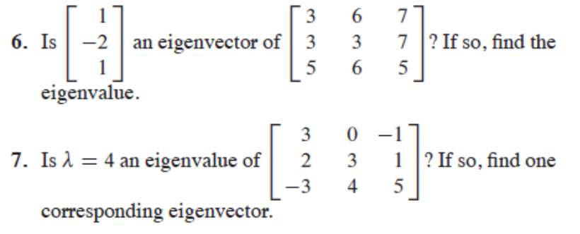
Sol:
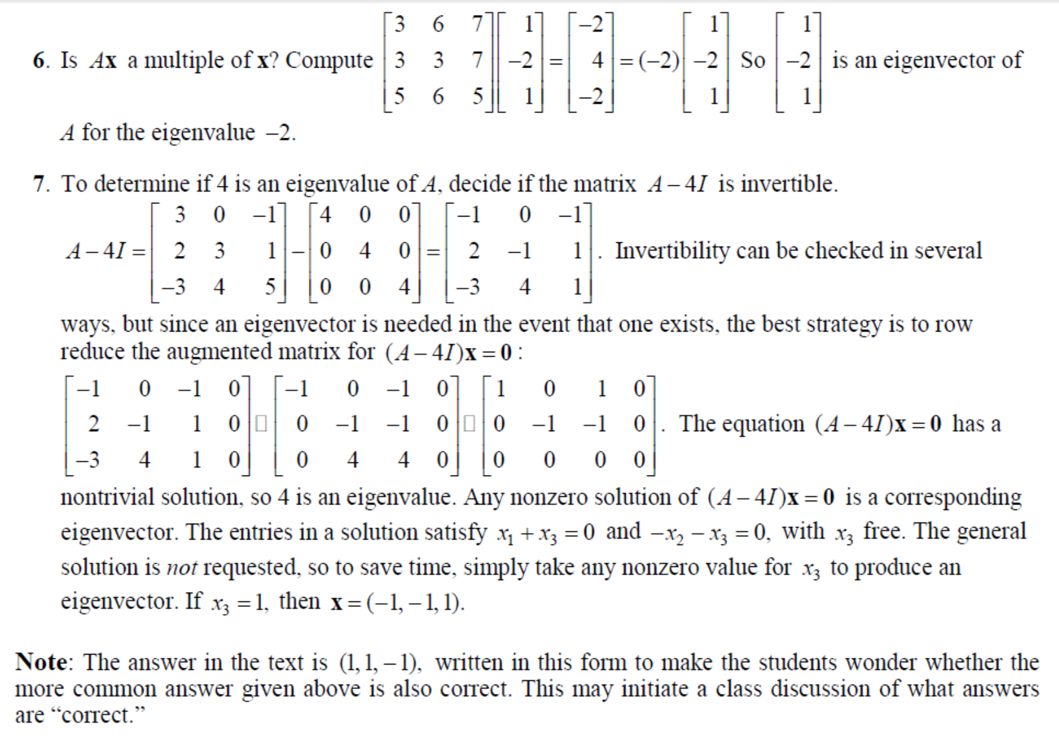
Q2: Find the eigenvalues & eigenvectors of
Solution:

Q3) Lay/Ch5/pg272/
Find an eigen -basis of the -2 eigenspace of A.
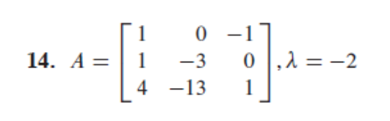
Ans: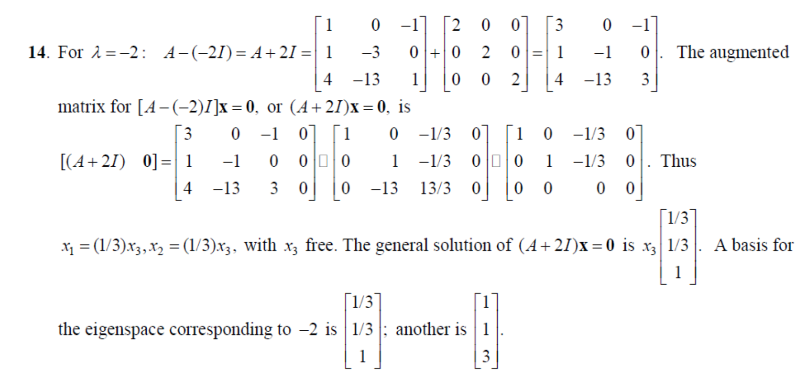

Q4: If {u,v} are linearly independent eigenvectors, then they must correspond to distinct eigenvalues.
False. Example in Q2 linearly independent eigenvectors, but with same eigenvalues!
Q5) Lay/ch5.1/pg 274/Q5
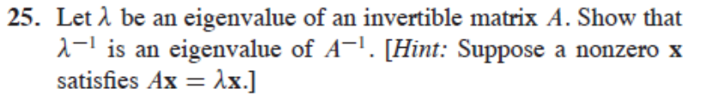
Sol:
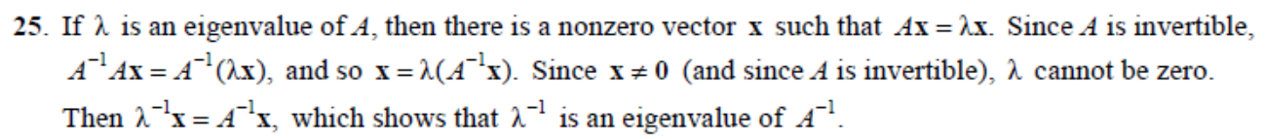

Q6) Lay/Ch5.3/pg288
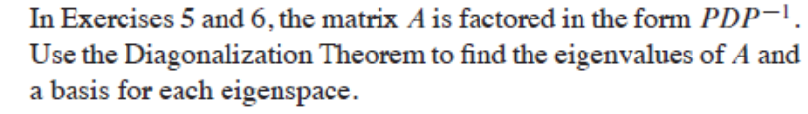
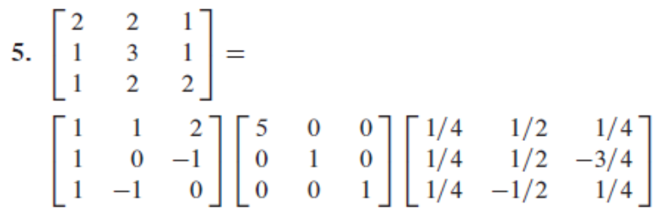
Sol:
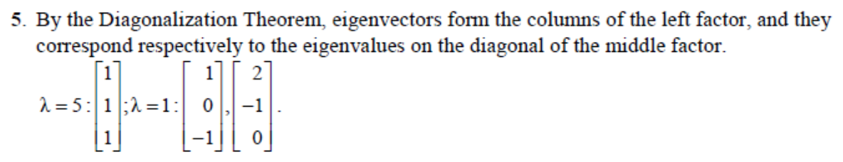

*Q7) Lay/Ch5.3/pg 289/Q21+23 *– I will cover this in class
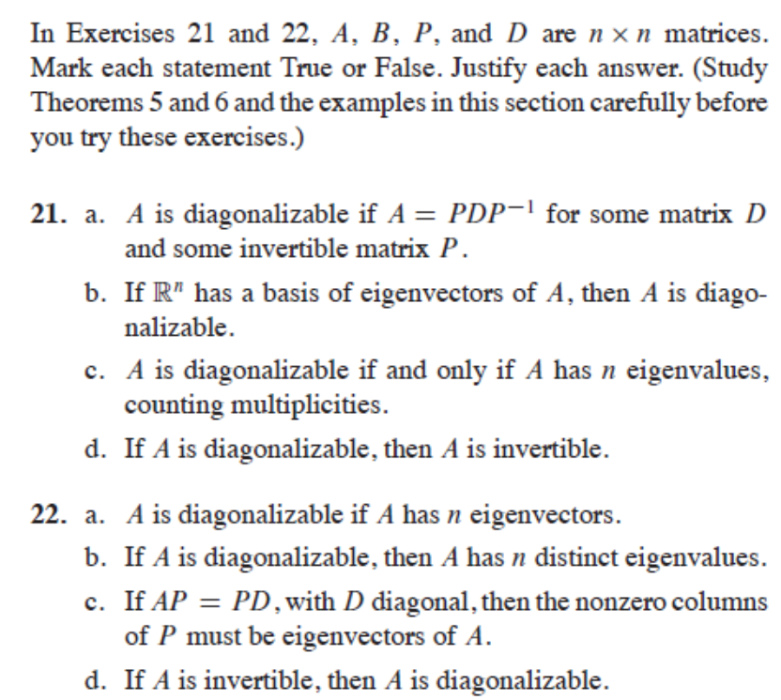
Sol:
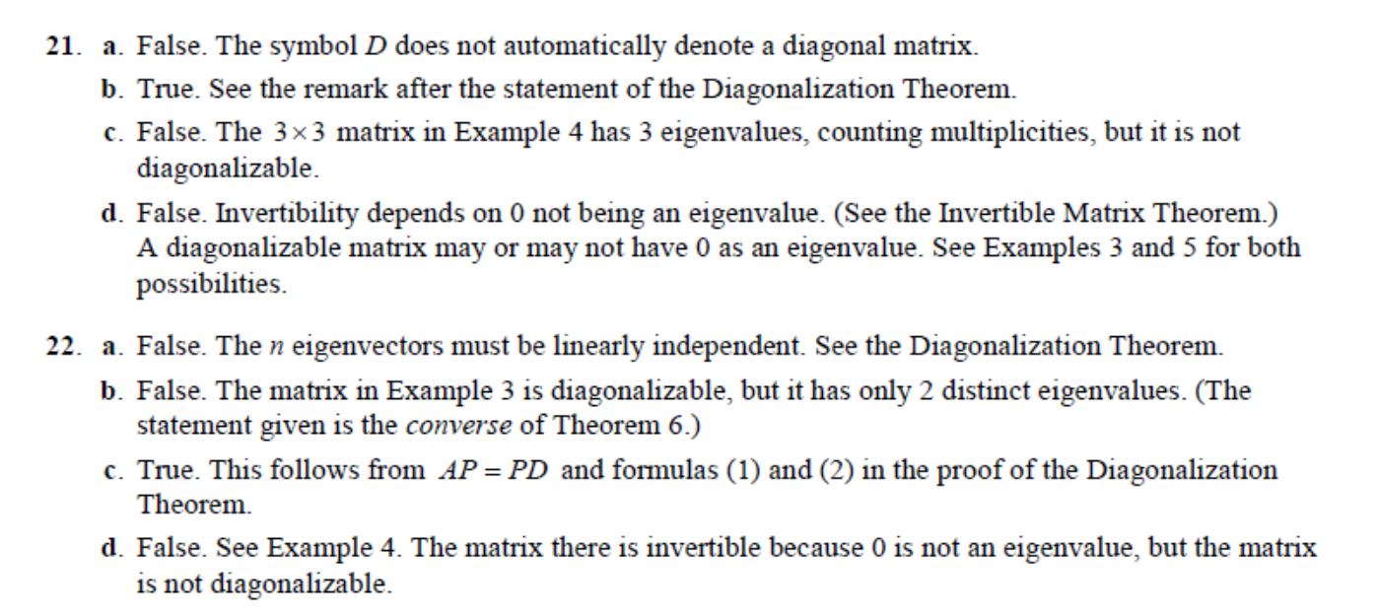
Q8) Lay./Ch5.3/pg289/Q31+32
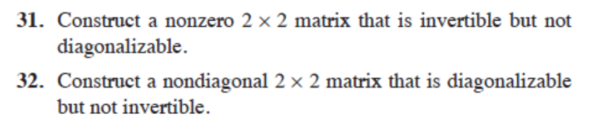
Sol:
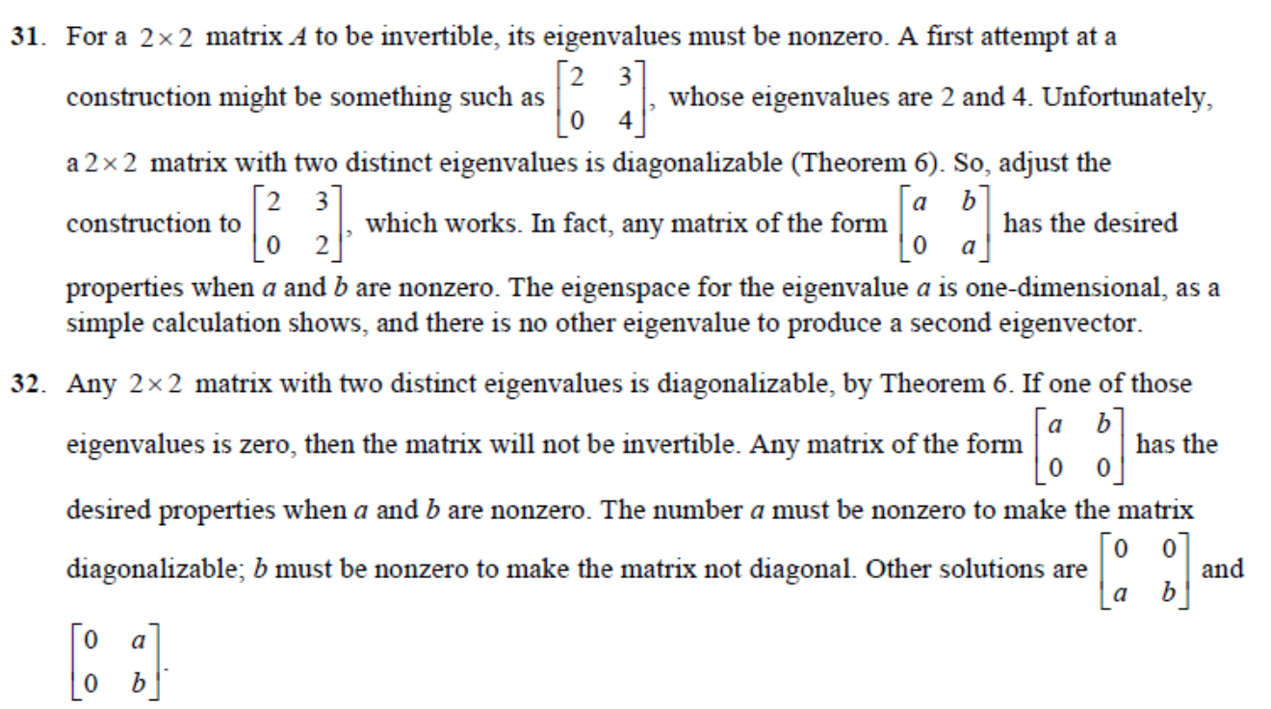

Q9) Lay/ch5.6/pg 311/Practise
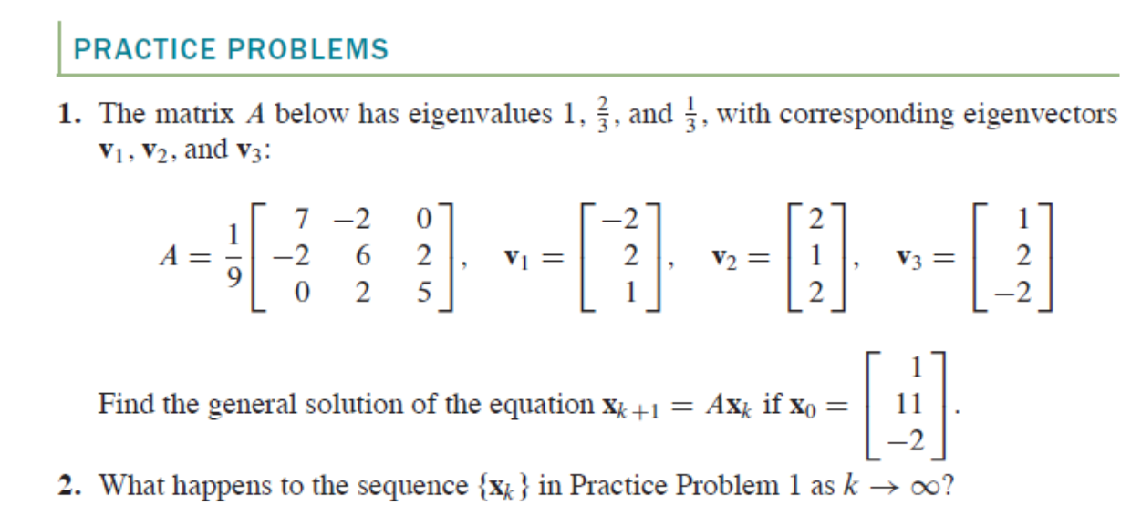

Sol:
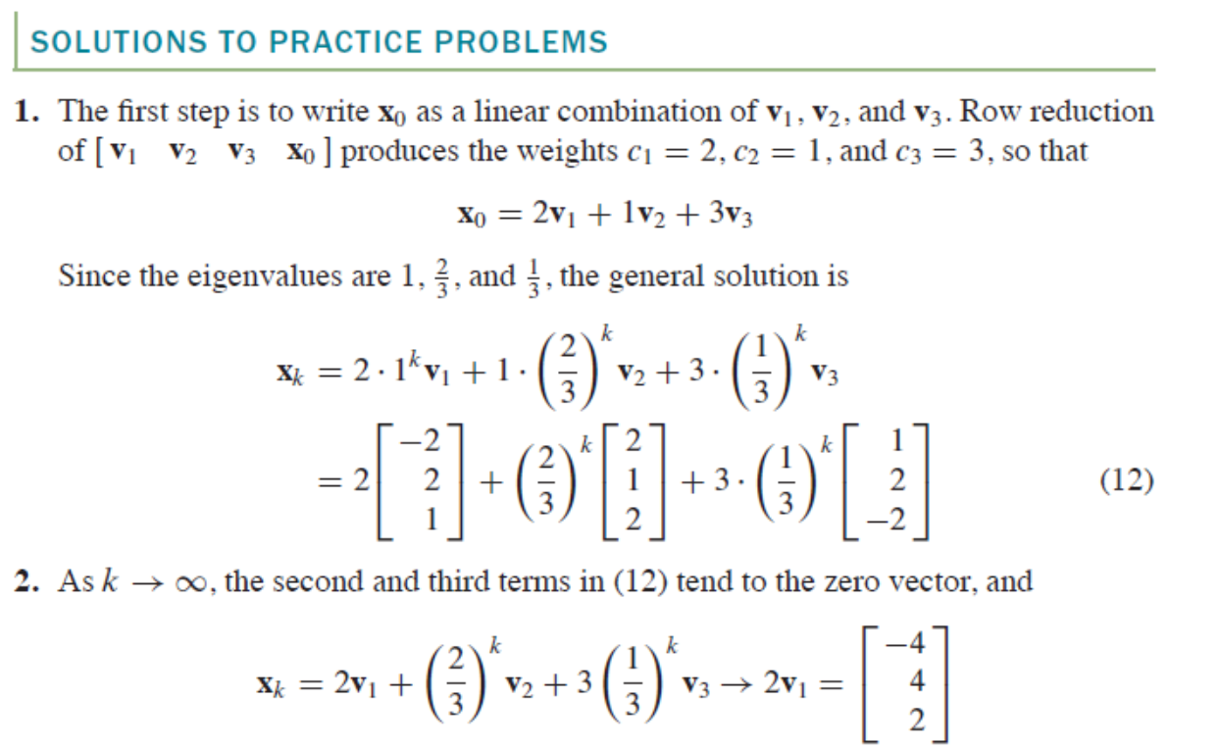

Q10:

Solution:

